Lecture 4:
Q1.Look at this picture. It is about things you are still learning about life. Talk about two of these six skills, lessons or experiences. Think before you answer. Give examples about them.
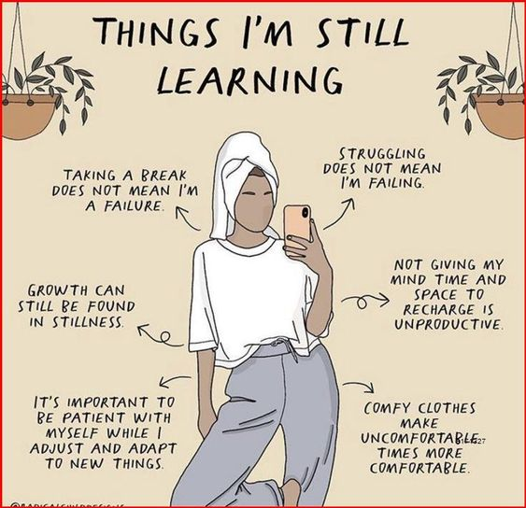
Q2. Look at this photo, and tell me the thing you understood from it. What is it about?

